**“template”** **PROJECT screenshot:**

**(PLEASE, this is JUST FOR REFERENCE, DO NOT turn it IN, INSTEAD TURN IN YOUR OWN “template conforming”** **PROJECT screenshot:**

**Step 1: Sample Screenshot (whole screen PRINT key on the keyboard will copy the screen with the following information:**

**Project, Output Window, Significant Source Code**

**Step 2: Open a word document and paste copy of the screen!**

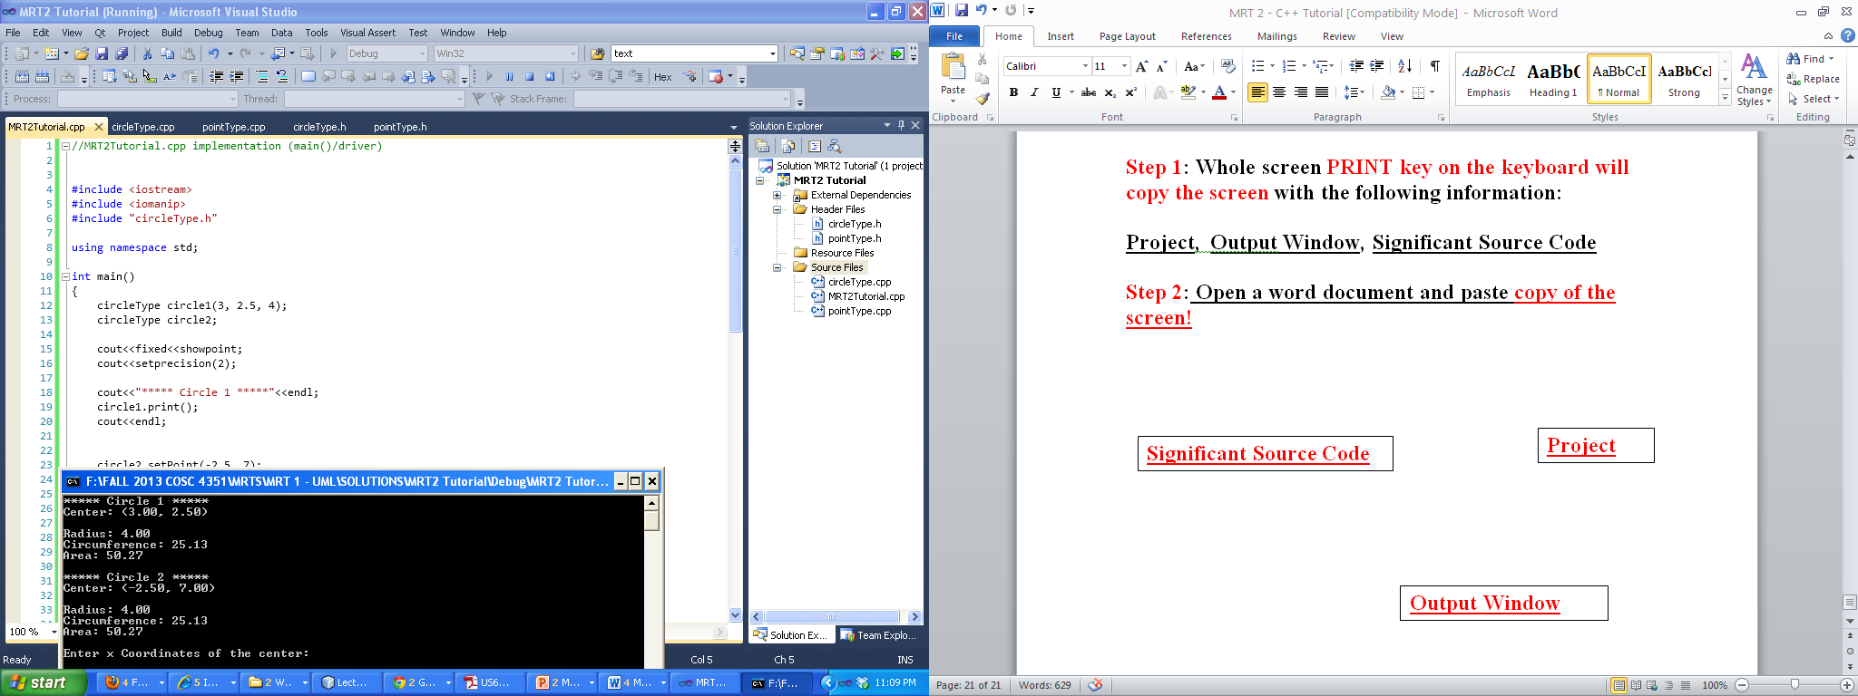

**Project**

**Significant Source Code**

**Output Window**